Supplementary material

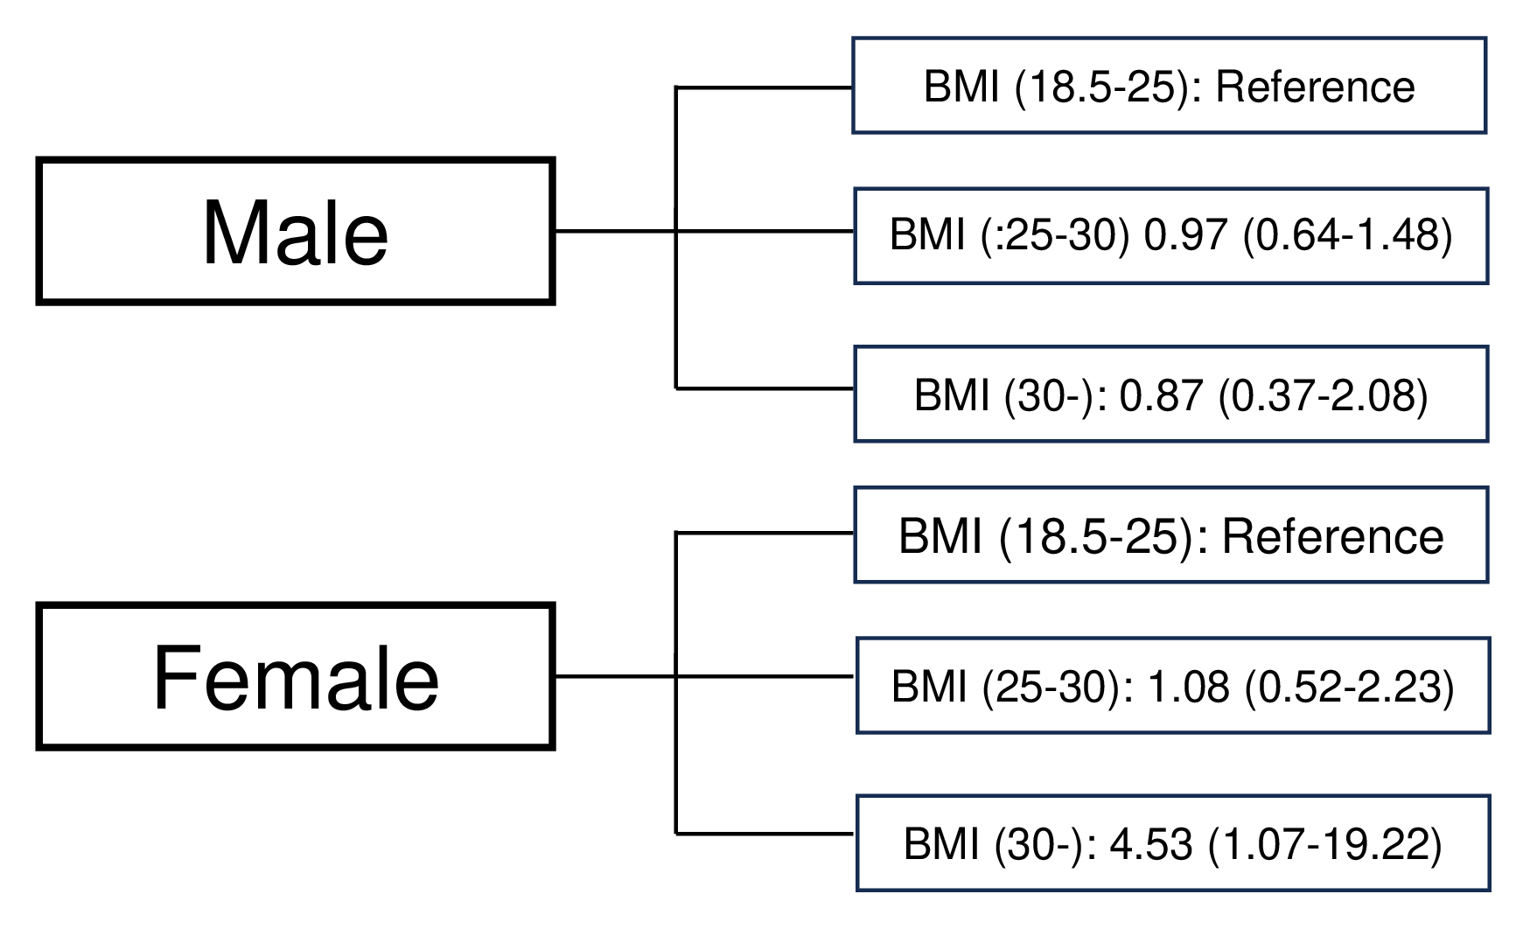
Supplementary Fig. 1. 1-month disability of TBI patients. BMI: body mass index.

